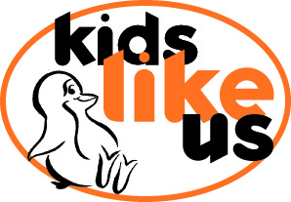
Registered Charity Number 1075335

Permissions

I confirm that I have read and agreed to your Health and Safety Policy.

I confirm that I have read and agreed to your Safeguarding Children Policy.
I understand Kids Like Us will have a First Aid kit at all events and will assist families to obtain the most appropriate treatment.
I give permission for photographs & video footage to be taken of my child. I understand that these will be used for a number of reasons listed below.

I understand that any photographs/video taken of my child will be available for me to view should I wish to do so before being used in any of the areas/applications listed below.

I give permission for you or the persons you have nominated to take photos/video of my child for the reasons indicated below:

To record the activities taken part in

I also understand that the photographs that have been taken of my child may be displayed in the following locations:

On your website.
On facebook
On Instrgram
On Twitter
On leaflets supporting future events and providing information and support to other parents

I understand that no payments will be made or taken for using photographs of my child in any of the above situations.

By giving us consent to use your image you need to understand that you can also withdraw your consent at any time. Should you wish to withdraw your permission you understand and accept that we will remove your images from our database and digital platforms within one month. Any images used in printed media will be replaced when the stock of that printed item is exhausted.

CHILDS NAME (PRINT) _______________________________________

PARENTS NAME (PRINT) ______________________________________

PARENT SIGNATURE ______________________________________

DATE _______________________________________

